**EXP11**

**Sort an array in ascending order.**

**CODE:**

#include<stdio.h>

void sort_array(){

int element[10],i,j,temp;

printf("enter 10 integer numbers:");

for(i=0;i<10;i++){

scanf("%d",&element[i]);

}

for(i=0;i<10-1;i++){

for(j=i+1;j<10;j++){

if(element[i]>element[j]){

temp=element[i];

element[i]=element[j];

element[j]=temp;

}

}

}

printf("Elements are now in ascending order:");

for(i=0;i<10;i++)

printf("%d\n",element[i]);

}

int main(){

sort_array();

return 0;

}

**OUTPUT:**

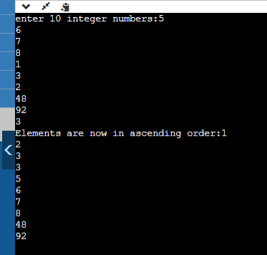

**Addition of 3x3 Matrix**

**CODE;**

#include <stdio.h>

void primatrix()

{

int a[3][3], i, j;

for (i = 0; i < 3; i++)

for (j = 0; j < 3; j++)

{

printf("Enter Element at %d%d position", i + 1, j + 1);

scanf("%d", &a[i][j]);

}

for (i = 0; i < 3; i++)

{

for (j = 0; j < 3; j++)

{

printf(" %d ", a[i][j]);

}

printf("\n");

}

}

void addmat()

{

int x, y, z, p, q, r, a, b, c;

printf("enter any 9 numbers :\n");

scanf("%d%d%d%d%d%d%d%d%d", &x, &y, &z, &p, &q, &r, &a, &b, &c);

printf("%d %d %d\n", x, y, z);

printf("%d %d %d\n", p, q, r);

printf("%d %d %d\n", a, b, c);

printf("Row total:%d %d %d\n", (x + y + z), (p + q + r), (a + b + c));

printf("column total: %d %d %d\n", (x + p + a), (y + q + b), (z + r + c));

printf("diagonal total :%d %d\n", (x + q + c), (a + q + z));

}

int main()

{

primatrix();

addmat();

return 0;

}